Sarasavi Library Software Project


Table of Contents
DIT2145 - SOFTWARE DEVELOPMENT PROJECT FINAL PROJECT (C# Programming)
1. Group Member & Work Division Details................................................................................3
2. Abstraction........................................................................................................................ 4
3. Objective of the Project.......................................................................................................5
4. Tools and Technologies Used..............................................................................................5
5. Functional Requirements....................................................................................................6
6. System Design ...................................................................................................................7
Use Case Diagram......................................................................................................7
ER Diagram................................................................................................................9
7.Project UI and Explanation................................................................................................ 11
Login Form...............................................................................................................11
System Main MDI Form............................................................................................. 12
Author Operations Form............................................................................................13
Add Author Form...........................................................................................13
List Author Form............................................................................................13
Publisher Operations Form....... ............................... .................................................14
Add Author Form....... ............................... ....................................................14
List Author Form....... ............................... ....................................................15
Book Operations Form.................. ...........................................................................16
Add Book Form.................. ...........................................................................16
List Book Form.................. ...........................................................................17
Member Operations Form.........................................................................................18
Add Member Form.........................................................................................18
List Member Form.........................................................................................19
Book Inquiry Form.....................................................................................................20
Loan Books Form......................................................................................................21
Return Books Form................................................................................................... 22
Reserve Books Form................................... ................ ................ ............................ 23
Report Operations Form ...........................................................................................25
8. Submit Software Development Project & Deployment Guidelines…………………………………..26

1. Group Member & Work Division Details
Photo | Student Name | Index Number | Contribution / Part Done
 | K.A.chamodee kavindya kekulawala | C60453 | Project Architect & Database Designer
 | S.P.T.ANURADHA ABEYSINGHE | C60556 | Backend Developer (Business Logic + OOP)
 | B .S. Chethana madhumali | C60913 | UI/UX Developer (WinForms + Ribbon / MaterialSkin)
 | Manthri Prathiraja Jayakodige Sadunika Randilini Jayakodi | C60393 | Reservation & Loan Module Specialist
 | J.D.I.U.Sudasinghe | C60254 | Testing, Security & Documentation Manager

2. Abstraction

A complete library management system called the “Sarasavi Library Software Project” is a desktop-based library software program that is meant to modernize and simplify the traditional library operations. The system is developed with the help of C# windows forms as user interface and Microsoft SQL server as the backend database and is built on the best.
Technologies to make sure it is stable, responsive and manages the data efficiently on the windows platform. The visually appealing theme of the application in the form of a chalkboard is one of its unique peculiarities. The design option is a combination of a traditional academic environment and the current digital features that add a modern appeal to the workspace, providing the librarian with a user-friendly and interacting work experience with the professional usability.
The system is organized based on a highly structured database schema of five tables as Users, Books, Copies, Loans, and Reservations. This architecture does not only maintain master. Records of book titles and library members but also maintains a record of individual physical copies of a book. The use of separate copy management allows the application to control inventory and monitor the availability of certain items correctly, which will allow managing the resources.
In terms of functionality, the program comprises a holistic selection of administrative solutions that facilitate the entire working process of a library. They consist of secure authentication system to protect data, full CRUD (Create, Read, Update, Delete) of the books and users, and advanced transactions that facilitate the circulation operations like issuing loan, handling returns and reservations.
The Sarasavi Library Software Project, in general, eliminates paper-based and error prone and manual procedures with an efficient, structured, and reliable digital solution, greatly enhancing the accuracy, productivity, and general efficiency in the management of the library.
3. Objective of the Project
The main goals of the project will be presented as follows:
- To come up with a safe, centralized, and effective digital system that will be able to oversee all the central operations of the library under one integrated system.
- Automating the full lifecycle of library inventory, including adding new titles of books, receiving single copies, tracking circulation operations and the exclusion of old and damaged materials.
- To implement a systematic and well-organized way of managing and updating the records of library members.
- To provide a backend logic to enforce library policies, including borrowing limits, user-type access privileges, as well as other circulation policies.
- To offer a high-tech and convenient search experience that helps to find the information about the book quickly and stay informed about its availability.
- To be able to manage the reservation process and notify the librarian about the pending requests in the case when the books are returned.
All these objectives have a common goal of increasing efficiency in operations, compliance in policies and general management of library resources.

4. Tools and Technologies Used
Category | Tools and Technology
Frontend | Windows Forms (C#)
Backend | C#.NET
Database | SQL Server
IDE | Visual Studio

5. Functional Requirements
- Authentication and Security
  - The system shall be protected by a secure login interface. Access to the administrative functions shall be granted only upon successful authentication using the following credentials:
    - Username: admin
    - Password: admin123

- Administrative Functionalities
  - The system shall provide the administrator with complete Create, Read, Update, and Delete (CRUD) capabilities for managing both book records and user records.
- Automatic Copy Generation
When a new book title is entered into the system, it shall automatically create the specified number of individual copy records and store them in the database.
- User Management Interface
The application shall include a dedicated interface that enables the administrator to view a comprehensive list of all registered users.

- Book Inquiry Module
The system shall provide a search functionality that allows users to locate books using:
      - Book Name
      - Author Name
      - Copy Number
- Business Rules Enforcement
  - The system shall enforce the following operational policies:
  - Visitors shall not be permitted to borrow or reserve books.
  - Books categorized as reference-only shall not be available for loan.
  - Members shall be limited to a maximum of five active book loans at any given time

6. System Design
• Use Case Diagram
The proposed library management application is designed around a single primary actor, namely the Librarian. The Librarian is responsible for managing and controlling all system functionalities. Access to the system is granted only after successful authentication. Once logged in, the Librarian can perform the following major use cases:
- Member Operations
This use case enables the Librarian to manage user accounts within the system. It includes:
- Registering new member
- Editing existing member profiles
- View member records
- Book Operations
This use case allows the Librarian to manage book records and their copies. It includes:
- Registering new book titles
- Editing book information
- View book titles and related copy records
- Deleting book titles and related copy records

- Author Operations
This use case allows the Librarian to manage Author records. It includes:
- Registering new Author
- Editing Author information
- View Author related records

- Publisher Operations
This use case allows the Librarian to manage Publisher records. It includes:
- Registering new Publisher
- Editing Publisher information
- View Publisher related records

- Book Inquiry
This use case provides the Librarian with the ability to search and view details of books available in the library collection.

- Loan, Return, and Reservation Management
This use case enables the Librarian to handle all circulation-related transactions, including:
- Issuing books to members
- Processing book returns
- Managing book reservations

In the Use Case Diagram, the Librarian actor is connected to all the above use cases, indicating full system access after authentication.
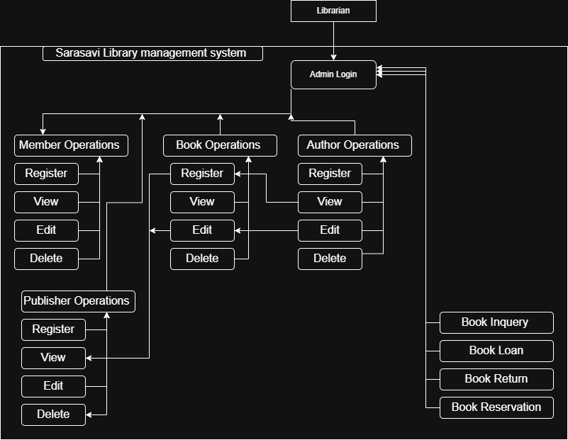
ER Diagram
The database design comprises of five interdependent tables namely; Users, Books, Copies, Loans and Reservations. The schema is also normalized fully to assure data integrity, reduce redundancy and facilitate operation of libraries effectively.
- Members Table
This table keeps all the information regarding the library patrons, their personal and membership information. Every record has a unique identification of a registered user into the system
- Authers Table
The Authers table contains the basic (main) data of the author title, including the author’s name.
- Publishers Table
The Publishers table contains the basic (main) data of the publisher title, including the publisher name.
- Books Table
The Books table contains the base (master) data of a particular book title, including book title name, Author ID, Publisher ID. The title of every book is registered once in this table.
- Copies Table
Copies table is the physical copies of single book titles. Identification of each copy is made. A foreign key (book id) creates a one-to-many relationships between the books and copies tables, with a single physical book title having several physical copies.
- Loans Table
Loans table keeps the record of borrowing transactions. It connects a particular User with a particular Copy. This table monitors the date of loans, date of returns and loan status.
- Reservations Table
Reservation table deals with book reservation requests. It connects a User to a book title of Books table. As opposed to Loans, reservations are linked to the master book record and not a particular copy. This relational design composed of order is to provide the appropriate enforcement of business rules and help manage the circulation activities effectively

Table Relationships Overview
- Authors & Publishers: Each Book is linked to exactly one Author and one Publisher (Many-to-One).
- Books & Copies: A Book (title) can have multiple physical Copies associated with it (One-to-Many). This allows tracking unique physical items like "Book Copy #0001".
- Loans: A Loan transaction connects a Member to a specific Copy. This tracks who has which physical book and when it is due (Many-to-One for both).
- Reservations: A Reservation connects a Member to a Book title (not a specific copy). This maintains the FIFO queue for the first available copy of that title.
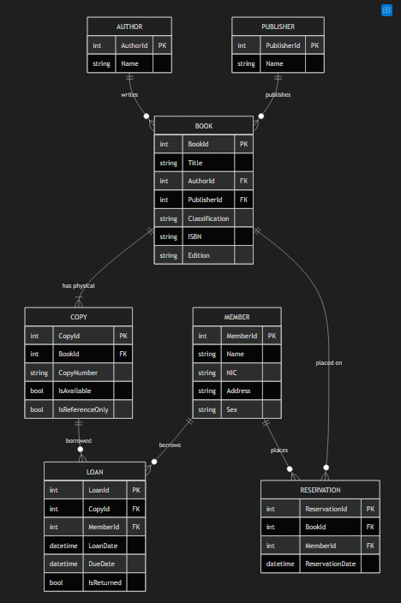

- Project UI and Explanation

The user interfaces (UI) are explained one by one below. The elements (buttons, etc.) used in each user interface (UI) and the functions performed by them are explained separately.

- Login Form
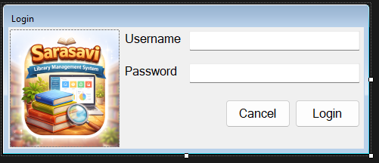
The secure entry point to the Library Management System is the Login Form. It ensures that access to the system is limited to approved staff to the features and administrative capabilities of the system.
User Interface Components and Functionalities
- Username and Password Fields These input fields enable the administrator to input his or her login credentials. The field of password is masked to ensure confidentiality and improve the security.
- Login Button Upon clicking the button of the Log-in, the system compares the stated credentials with the defined authentication data. In the case of the validity of the credentials the system will allow access and redirections to the System Main MDI Form interface. In case the credentials are invalid an access is denied and a suitable message of error is shown. This type is essential in ensuring the security of the systems as well as avoiding unauthorized entry.
- Cancel Button Exits the application immediately if the user decides not to log in.

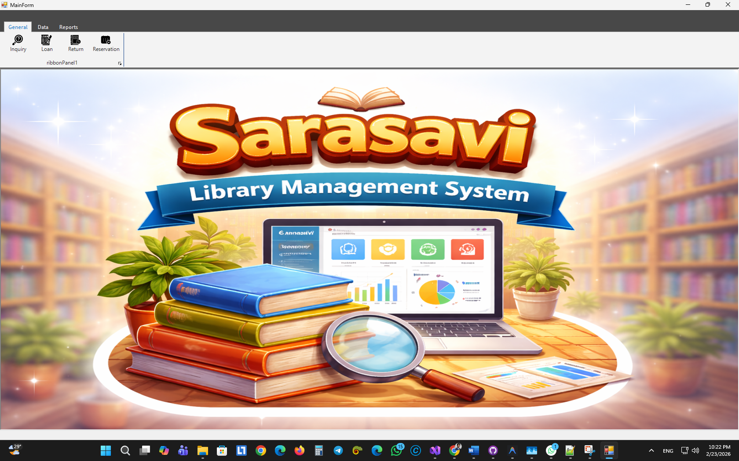
- System Main MDI Form

The Main MDI (Multiple Document Interface) Form serves as the central hub of the application. it provides a structured navigation system to access all other modules of the library system.
User Interface Components and Functionalities
- Ribbon Navigation System The top of the form features a Ribbon control organized into tabs (General, Data, Reports) and panels (Books, Authors, Publishers, Members).
  - General Tab: contains buttons for Inquiry, Loan (Borrow), and Return operations.
  - Data Tab: contains dedicated panels for managing Books, Authors, Publishers, and Members, each with "Add" and "Find" buttons.
  - Reports Tab: provides access to the Borrow History and other usage reports.
- MDI Container The central area of the form is an MDI container where all child forms (e.g., Book List, Member Add) are opened and managed within a single window.
- Status Bar A status bar at the bottom displays a loading progress bar to indicate when background data operations are in progress.

- Author Add/Edit Form
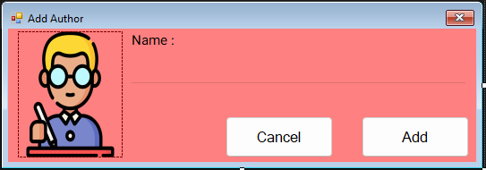
This form is used to either add a new author to the database or modify the details of an existing one.
User Interface Components and Functionalities
- Author Name Field A text input field for entering or editing the full name of an author.
- Submit (Add/Update) Button Saves the author details to the database. It validates that the name field is not empty before proceeding.
- Cancel Button Closes the form without saving any changes.

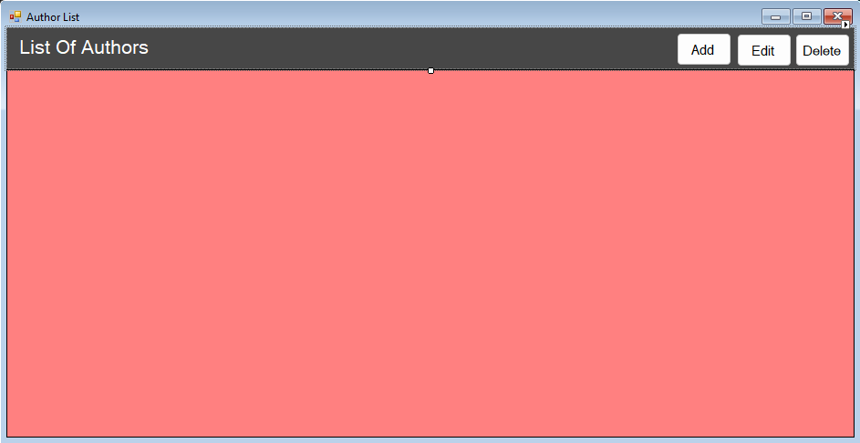
- Author List Form

Provides a comprehensive view of all authors registered in the system.
User Interface Components and Functionalities
- Author Data Grid Displays a list of authors, including their names and the count of books associated with them.
- Add Button Opens a blank Author Add Form to register a new author.
- Edit Button Opens the selected author's details in the Author Edit Form for modification.
- Delete Button Removes the selected author from the system. It includes a safety check to prevent deletion if the author has books currently linked to them.

- Publisher Add/Edit Form

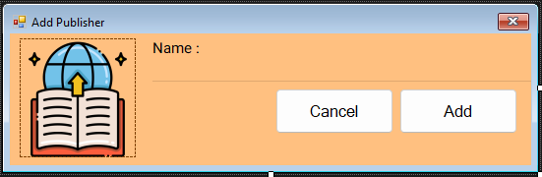
Used for registering new publishers or updating the information of existing ones.
User Interface Components and Functionalities
- Publisher Name Field A text input field for entering the official name of the publishing house.
- Submit Button Records the publisher's data into the system database after validating the input.
- Cancel Button Dismisses the form without performing any data operations.

- Publisher List Form

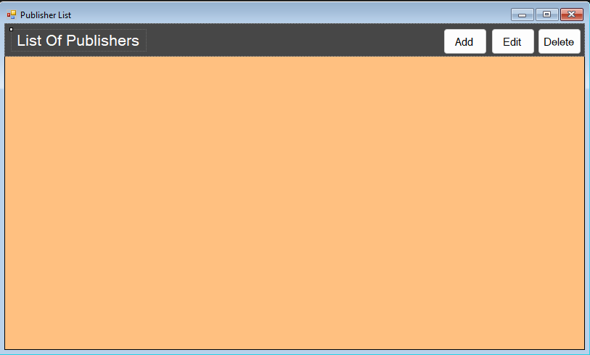
Displays all publishers stored in the library's database.
User Interface Components and Functionalities
- Publisher Data Grid Shows a tabular view of publishers and their respective book counts.
- Management Buttons (Add, Edit, Delete) Allows for full CRUD (Create, Read, Update, Delete) operations on publisher records. Similar to authors, deletion is restricted for publishers with active book associations.

- Book Add Form

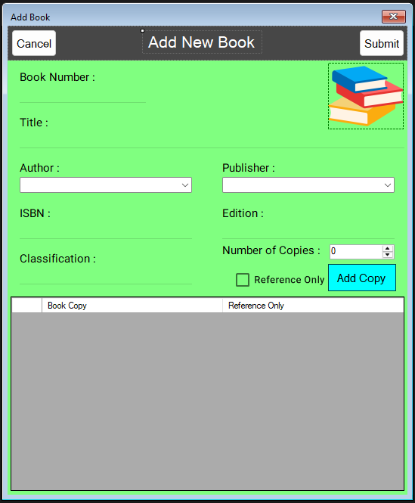
The primary interface for adding new book titles and their individual copies into the library inventory.
User Interface Components and Functionalities
- Book Details Fields Includes fields for Title, ISBN, Edition, and Classification.
- Dropdown Selections (Author & Publisher) Enables the user to select from existing authors and publishers, ensuring data consistency.
- Number of Copies Input A numeric selector to specify how many physical copies of the book are being added.

- Reference Only Checkbox Determines if the book (or specific copies) is for reference purposes only and cannot be borrowed.
- Book Copy Grid A dynamic grid that lists each individual copy being added, allowing fine-grained control over the "Reference Only" status for each specific book copy.
- Submit Button Executes the multi-step process of adding the book definition and then generating individual copy records in the database.

- Book List Form

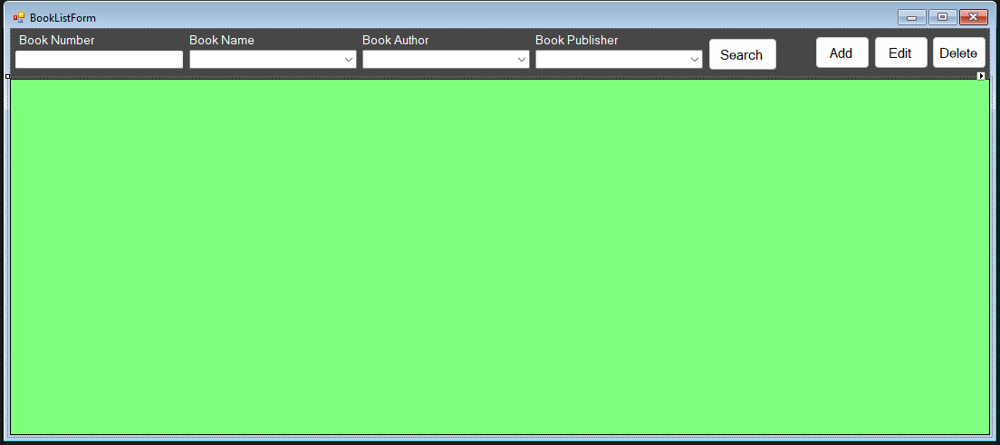
A sophisticated search and management interface for the library's book collection.
User Interface Components and Functionalities
- Search Filters Enables filtering the book collection by Book Number, Name, Author, or Publisher.
- Data Grid View Displays detailed information about book copies, including their current availability status.
- Integration with Add/Edit Features buttons to quickly jump to the Book Add Form or edit/delete existing records.

- Member Add/Edit Form

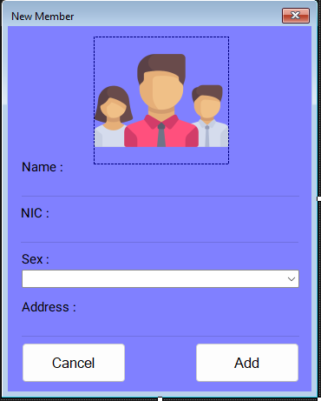
Used to register new library members or update their profile information.
User Interface Components and Functionalities
- Personal Information Fields Includes text fields for Name, NIC (National Identity Card), and Address.
- Sex Selection Dropdown Allows choosing between Male and Female for demographic data.
- Submit (Add/Update) Button Validates all required fields and ensures NIC uniqueness before saving the member record.
- Cancel Button Closes the form without saving.

- Member List Form

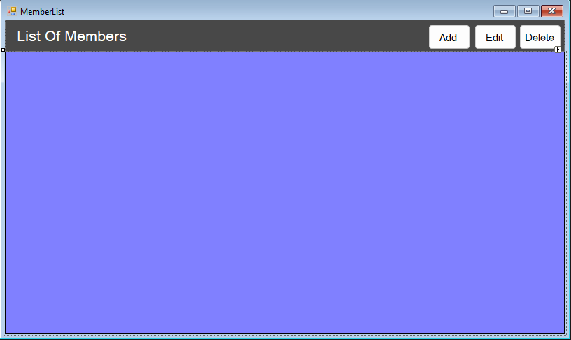
A central repository for viewing and managing all library members.
User Interface Components and Functionalities
- Member Data Grid Displays a comprehensive list of members with their NIC, Address, and contact details.
- Management Actions Includes buttons for Adding, Editing, and Deleting members. Deletion is restricted if a member has active loans or outstanding issues.

- Inquiry Form

- 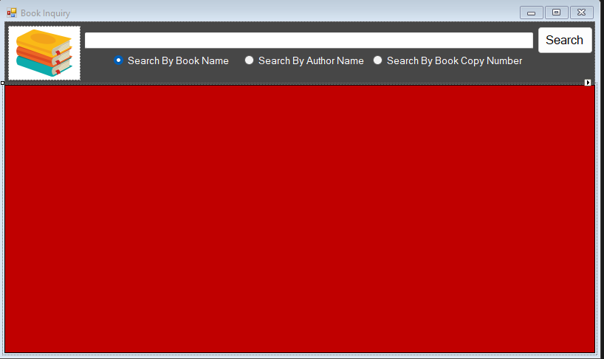
A dedicated search tool for both staff and potentially library visitors to find books.
User Interface Components and Functionalities
- Search Type Selection Radio buttons allow users to toggle between searching by Book Name, Author Name, or specific Copy Number.
- Search Box and Button The main input area for the search query and the trigger to execute the search.
- Results Grid Displays all matching books and their location/availability details.

- Loan (Borrow) Form

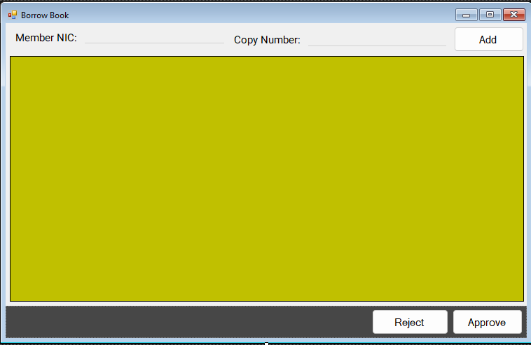
The Loan Form is the core transactional interface for the library's circulation desk. It facilitates the process of lending book copies to registered members while strictly enforcing library policies through real-time validation. This form is designed to handle multi-book transactions efficiently within a single session.
User Interface Components and Functionalities
- Member Authentication (NIC Search) Equipped with a MaterialSingleLineTextField for the member's National Identity Card (NIC) number, this component allows staff to uniquely identify the borrower. The system uses this to retrieve the member's profile and check their current standing (active loans, overdue status) before proceeding with any transaction.
- Book Copy Entry System A secondary input field specifically for the unique Copy Number of physical books. This allows staff to quickly add items to a temporary borrowing list. The system performs immediate checks upon entry to ensure the copy is actually available in the stacks and is not designated as "Reference Only."
- Dynamic Loan Transaction Grid A central DataGridView that functions as a "borrowing cart." It displays the Copy Number, Book Name, Loan Date (auto-set to the current date), and a calculated Due Date (standardized to 14 days from the loan date). This allows staff and members to review the selected items before finalizing the loan.
- Policy Enforcement Logic (Business Rules) The form integrates advanced validation logic that triggers during the staging and finalization phases:
  - Inventory Status Check: Prevents borrowing items that are already marked as borrowed or reserved.
  - Resource Classification Check: Intercepts attempts to borrow reference-only materials that are restricted to in-library use.
  - Member Loan Ceiling: Enforces a maximum limit of 5 active loans per member at any given time.
  - Overdue Block: Automatically denies new borrowing privileges if a member has any currently overdue items in their possession.
- Transaction Controls (Approve & Reject)
  - Approve Button: Once the borrow list is verified, this button commits the transaction to the database, creates the loan records, and updates the book status repository.
  - Reject (Cancel) Button: Provides a quick-exit path to clear the current transaction screen without saving any changes, ensuring data integrity in case of member withdrawal or data entry errors.

- Return Form
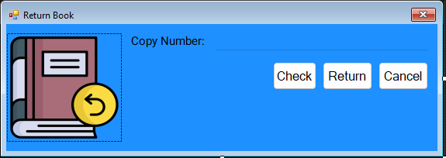
Used to process the return of borrowed books and manage reservations.
User Interface Components and Functionalities
- Copy Number Entry Input for the unique identifier of the book being returned.
- Check Button Retrieves the active loan information, showing who borrowed the book and identifying any potential delays.
- Return Button Finalizes the return, marking the book as "Available" in the system.
- Reservation Alert System Upon return, the system automatically checks if another member has reserved this book. If a reservation exists, a notification is shown to the staff.

- Reservation Form

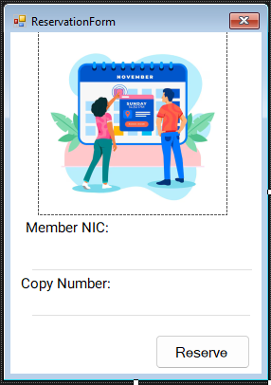
The Reservation Form manages the library's "First-In, First-Out" (FIFO) queuing system. It allows members to place holds on book titles that currently have no available copies in circulation, ensuring a fair and organized process for accessing high-demand materials.
User Interface Components and Functionalities
- Member-to-Title Linking This interface enables staff to register a reservation by linking a specific Member ID to a Book Title. Unlike loans which are copy-specific, reservations are placed at the title level, allowing the member to be notified as soon as any physical copy of that book is returned to the library.
- Reservation Queue Management The system maintains a chronological list of member requests for each book. This FIFO queue ensures that the member who waited the longest is the first to be notified when a copy becomes available, maintaining transparency and fairness in resource allocation.
- Integration with Return Logic While the Reservation Form handles the creation of entries, it is tightly coupled with the system's back-end logic. During the return process (via the Return Form), the system automatically queries the Reservation Repository to identify if a queue exists for the returned item.
- Automated Fulfillment and Notification When a relevant book copy is returned:
  - The system identifies the oldest reservation in the queue.
  - An automated alert is generated for library staff to notify the member (displaying their name and NIC).
  - Upon successful notification or processing, the system provides the capability to remove the fulfilled reservation from the active queue.
- System Status Inquiry Works in conjunction with the Inquiry Form to provide real-time updates on a book's "Reservation Status," allowing staff to inform members about the length of the current queue or their position within it.

- Report Form

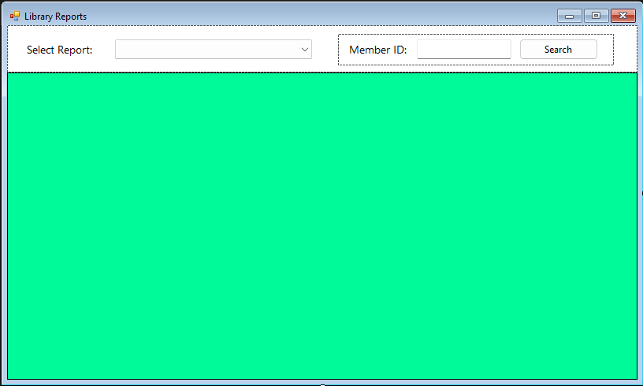
The Report Form is the system's primary analytical module, providing administrative staff with actionable insights into library operations. It features a multi-modal interface that dynamically adapts its filtering capabilities based on the specific dataset being analyzed, from circulation history to member-specific activity and active reservations.
User Interface Components and Functionalities
- Dynamic Report Selector A central ComboBox allowing staff to switch between critical reporting modes. The form’s layout dynamically reconfigures itself upon selection, toggling visibility for context-specific search panels and filter groups.
- Context-Adaptive Search Panels
  - Member Identification Panel: Activated for "Member History" reports, this panel requires a valid numeric Member ID to retrieve a granular log of an individual's borrowing activity.
  - Circulation Filter Panel: Activated for "Borrowed History," this group contains radio buttons and checkboxes to isolate "Active" vs. "All" loans or specifically target delayed/overdue transactions.
- Intelligent Data Visualization Grid A customized DataGridView that serves as the reporting canvas. It includes automated column resizing for readability and advanced
CellFormatting logic:
  - Visual Overdue Alerts: The system automatically scans the data and highlights entries with a "Delay Return" status in bright Red, providing immediate visual cues for staff to prioritize follow-up actions.
- Comprehensive Analytical Suites
  - Borrowed History: Provides a macro view of the library's circulation, including checkout dates, return statuses, and late-return flags.
  - Member History: Offers a micro view of an individual member's relationship with the library, useful for resolving disputes or evaluating borrowing patterns.
  - Reservation Analytics: Displays a real-time log of the library's hold queue, including book titles, member details (Name and NIC), and the date the reservation was placed.
- Error-Resilient Data Loading Integrated validation ensures that search queries (like Member IDs) are correctly formatted before executing database calls, while comprehensive try-catch blocks prevent system interruptions during large-scale data processing.

- Submit Software Development Project & Deployment Guidelines

Deployment Guidelines - Sarasavi Library Management System
This guide outlines the steps required to set up and deploy the Sarasavi Library Management System on a new workstation.

1. Prerequisites
Ensure the following software is installed on the deployment machine:
- Operating System: Windows 10 or higher.
- Framework: .NET Framework 4.7 or higher.
- Database: SQL Server LocalDB (usually installed with Visual Studio or as a standalone component).
- IDE (Optional): Visual Studio 2019 or newer (for building from source).

2. Database Setup
The application features a semi-automatic database initialization process:

- Manual Catalog Creation (Required):
  - The initial database catalog (named SarasaviDB) must exist on the LocalDB instance (localdb)\ProjectModels before the application can start.
  - If it does not exist, use SQL Server Object Explorer to manually create a new database named SarasaviDB.
- Automatic Table & Schema Creation:
  - Once the catalog exists, the application's DatabaseInitializerService.cs will automatically create all necessary tables, columns, and initial constraints during the first launch (splash screen phase).
  - It also seeds a default administrative account (admin / admin123).

- Verify Connection String:
  - Ensure the App.config file in the application root matches the local database instance:
    - <connectionStrings>
    - <add name="LibraryDB"
    - connectionString="Data Source=(localdb)\ProjectModels;Initial Catalog=SarasaviDB;Integrated Security=True"
    - providerName="System.Data.SqlClient" />
    - </connectionStrings>

Post-Deployment Configuration
Credentials: The default administrator credentials are usually initialized during database setup.
External Libraries: Ensure MaterialSkin.dll and RibbonWinForms.dll are present in the same folder as the .exe.
Permissions: Ensure the user running the application has read/write permissions to the deployment folder for log files or temporary data.

Project The complete software project, including all C# source code, design files, and the database schema, is finalized and ready for submission.
User name– admin
Password- admin123
Drive Link- https://drive.google.com/file/d/1OMtrVVRQyccGFdfq5oDfW4-ICdJuzlrO/view?usp=sharing

